**ONLINE MOVIE TICKET BOOKING SYSTEM**

***(Dr. D.Y. Patil Institute of Engineering and Technology, Pimpri, Pune-411018)***

**STUDENT DETAILS:**

1)Chinmay Padole (Team Leader)

2)Shameem Choudhary

3)Himanshu Satav

AIM:

The project was concerned with developing an online movie ticket booking system (application) with various features in it.

REQUIRMENTS:

Windows 7/8/9/10

Internet connectivity.

DESCRIPTION:

In this project, we have limited and fixed some movie shows that will be playing in our virtual theatre system, which can be booked by our movie ticket booking system software.

The system will auto generate a mail when you confirm your seats for a show at particular day, date and time and will mail it to you.

There are 2 screens running throughout the day, with 6 movies playing in a day (3 in one screen, 3 in another).

The ticket can also be printed if one wishes to do so. The cash needs to be paid at the virtual theatre for getting your entry.

ADVANTAGES:

* We took efforts to make the UI look decent and be user friendly at the same time.
* There are no Logical errors at this moment in the program.
* You can receive a mail after your ticket confirmation.
* The main aim of the project to book a movie ticket was successfully achieved.

DISADVANTAGES:

* The main disadvantage is that, since we have used “VARCHAR(MAX)” as our datatypes in the database and the “VARCHAR(MAX)” also has a specified size limit, after crossing that limit my movie ticket booking system won’t work properly. This is because I am storing the date of booking as well as the persons ID in the column per ticket booked, this will cross the “VARCHAR(MAX)” size limit pretty soon.
* When we take print of the document, there appears a white rectangle on the top left side of screen for no reason.
* Work on Admin panel is not yet finished.
* Old booked dates are not clearing up and are clustering up in database.(can’t create a log file for them).

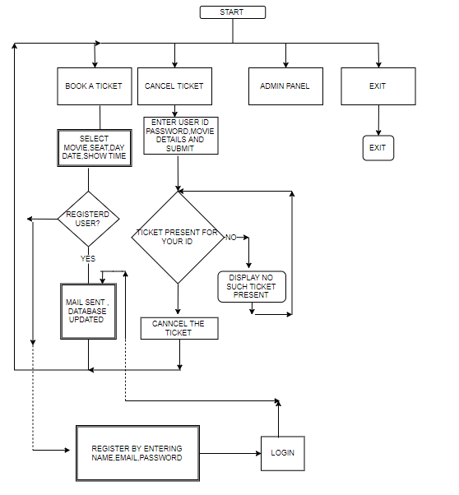FLOWCHART:

PROJECT GUIDE NAME**: *RASHMI CHAUDHARI (MAM)***